**Problem 1: Research Projects Database**

Design an Entity-Relationship schema for a database of research projects. The database should contain the information about projects, which include their name, manager, budget, duration in years, and funding agency; employees, who have SSN, name, salary, and can work on multiple projects; and funding agencies, which have name and address. Each project is funded by a single agency. Project names are unique within an agency. An employee can be associated with several projects and managers are also employees. You can make any other additional assumptions that make sense in the real world.

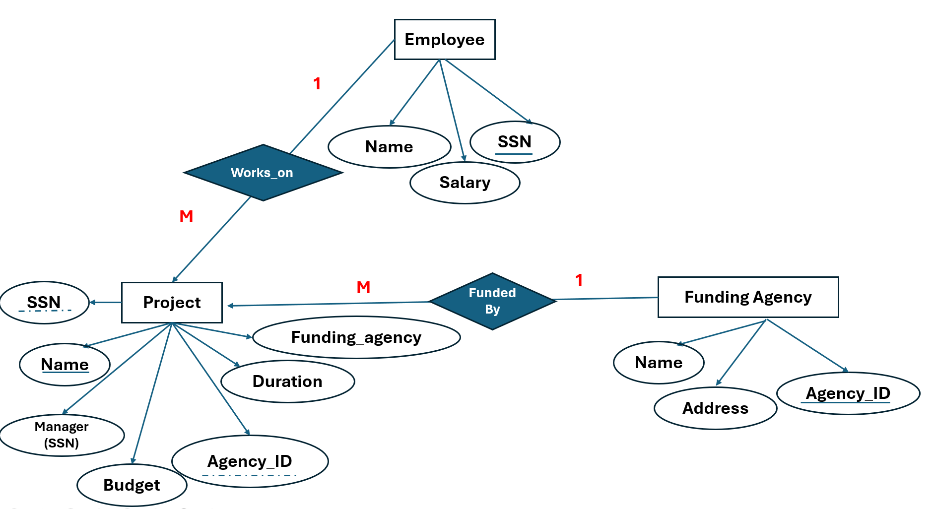

### 

### 

### 

### 

### **🧾 SQL Table Creation Statements:**

#### **1. Employee Table**

CREATE TABLE Employee (

SSN INT PRIMARY KEY,

Emp_Name VARCHAR(50),

Salary DECIMAL

);

#### **2. FundingAgency Table**

CREATE TABLE FundingAgency (

Agency_ID INT PRIMARY KEY,

Name VARCHAR(100),

Address VARCHAR(255)

);

#### **3. Project Table**

CREATE TABLE Project (

Project_ID INT PRIMARY KEY,

Name VARCHAR(100),

Duration INT, -- Assuming duration in days/months

Budget DECIMAL(12, 2),

Agency_ID INT,

FOREIGN KEY (Agency_ID) REFERENCES FundingAgency(Agency_ID),

);

#### **4. Employee_Project Junction Table**

CREATE TABLE Employee_Project (

SSN INT,

Project_ID INT,

Manager_SSN INT,

PRIMARY KEY (SSN, Project_ID),

FOREIGN KEY (SSN) REFERENCES Employee(SSN),

FOREIGN KEY (Project_ID) REFERENCES Project(Project_ID),

FOREIGN KEY (Manager_SSN) REFERENCES Employee(SSN)

);

#### **5. Project_Manager Table**

CREATE TABLE Project_Manager (

Project_ID INT PRIMARY KEY,

Manager_SSN INT,

FOREIGN KEY (Project_ID) REFERENCES Project(Project_ID),

FOREIGN KEY (Manager_SSN) REFERENCES Employee(SSN)

);

-- 1) Employee

INSERT INTO Employee (SSN, Emp_Name, Salary) VALUES

(101, 'John Doe', 55000.00),

(102, 'Jane Smith', 65000.00),

(103, 'Alice Brown', 72000.00);

-- 2) FundingAgency

INSERT INTO FundingAgency (Agency_ID, Name, Address) VALUES

(201, 'Tech Research Fund', '123 Tech Ave, Silicon Valley, CA'),

(202, 'Innovation Grants Inc.', '456 Innovation Dr, New York, NY'),

(203, 'Global Funding Group', '789 Global St, London, UK');

-- 3) Project

INSERT INTO Project VALUES

(301, 'AI Research', 12, 200000.00,201),

(302, 'Cloud Migration', 18, 300000.00,202),

(303, 'Blockchain Platform', 24, 400000.00,202);

-- 4) Project_Manager (one manager per project)

INSERT INTO Project_Manager (Project_ID, Manager_SSN) VALUES

(301, 101),

(302, 102),

(303, 103);

-- 5) Employee_Project (who works on which project, with that project’s manager)

INSERT INTO Employee_Project (SSN, Project_ID, Manager_SSN) VALUES

(101, 301, 101), -- John manages & works on AI Research

(102, 302, 102), -- Jane manages & works on Cloud Migration

(103, 303, 103); -- Alice manages & works on Blockchain Platform

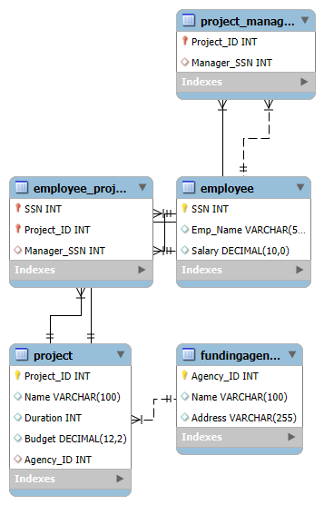

/* === TABLES For Copy Pasting ===== */

CREATE TABLE Employee (

SSN INT PRIMARY KEY,

Emp_Name VARCHAR(50),

Salary DECIMAL

);

CREATE TABLE FundingAgency (

Agency_ID INT PRIMARY KEY,

Name VARCHAR(100),

Address VARCHAR(255)

);

CREATE TABLE Project (

Project_ID INT PRIMARY KEY,

Name VARCHAR(100),

Duration INT, -- e.g. months

Budget DECIMAL(12,2)

);

CREATE TABLE Employee_Project (

SSN INT,

Project_ID INT,

Manager_SSN INT,

PRIMARY KEY (SSN, Project_ID),

FOREIGN KEY (SSN) REFERENCES Employee(SSN),

FOREIGN KEY (Project_ID) REFERENCES Project(Project_ID),

FOREIGN KEY (Manager_SSN)REFERENCES Employee(SSN)

);

CREATE TABLE Project_Manager (

Project_ID INT PRIMARY KEY,

Manager_SSN INT,

FOREIGN KEY (Project_ID) REFERENCES Project(Project_ID),

FOREIGN KEY (Manager_SSN)REFERENCES Employee(SSN)

);

/* === DATA INSERTS ============================================ */

INSERT INTO Employee (SSN, Emp_Name, Salary) VALUES

(101, 'John Doe', 55000.00),

(102, 'Jane Smith', 65000.00),

(103, 'Alice Brown', 72000.00);

INSERT INTO FundingAgency (Agency_ID, Name, Address) VALUES

(201, 'Tech Research Fund', '123 Tech Ave, Silicon Valley, CA'),

(202, 'Innovation Grants Inc.', '456 Innovation Dr, New York, NY'),

(203, 'Global Funding Group', '789 Global St, London, UK');

INSERT INTO Project (Project_ID, Name, Duration, Budget) VALUES

(301, 'AI Research', 12, 200000.00),

(302, 'Cloud Migration', 18, 300000.00),

(303, 'Blockchain Platform', 24, 400000.00);

INSERT INTO Project_Manager (Project_ID, Manager_SSN) VALUES

(301, 101),

(302, 102),

(303, 103);

INSERT INTO Employee_Project (SSN, Project_ID, Manager_SSN) VALUES

(101, 301, 101),

(102, 302, 102),

(103, 303, 103);